Comparison of the Operating Characteristics of Variable Selection Techniques
Marshall Roll
Introduction
This project seeks to understand the operating characteristics of common variable selection techniques in linear regression. The performances of five model selection methods were investigated on a simulated dataset: backward selection using F-tests and p-values, AIC, and BIC as well as LASSO and elastic net regularization. Backward selection begins with a full model and sequentially removing the explanatory variable that contributes the least to model fit until a pre-specified stopping criterion is met. Regularization methods apply a shrinkage penalty directly to the coefficients, so variables with low predictive power are “zeroed out.” The simulated dataset contained some explanatory variables with a true relationship to the outcome and others without a true relationship; the overall goal of model selection algorithms is to correctly select variables with a true signal (sensitivity) and to exclude the variables representing random noise (specificity). Additionally, the final models generated by each selection algorithm over all simulation iterations were evaluated to determine the accuracy with which parameters were estimated (bias) and the uncertainty surrounding these estimates (coverage). Together, these measures elucidate the characteristics of each variable selection algorithm and help to motivate their appropriate use.
Methods
All analysis was completed in R version 4.5.1. The three backward selection techniques were carried out with the stepAIC function in the MASS package. In backward selection using F-tests and p-values, a threshold of 0.05 was used for model significance.¹ For both regularization methods, the cv.glmnet function in the glmnet package was used. Two choices of the penalty parameter will be tested: the minimum mean cross-validated error (λ_{min}), and a penalty parameter one standard error larger than the minimum (λ_{1se}). In elastic net, the parameter that controls between the mixing of the two penalty types was selected using a grid search to minimize its mean cross-validated error.² Normally distributed data was simulated using the hdrm package in R with a set seed under six scenarios. In each scenario, 20 total explanatory variables were simulated with 5 truly meaningful predictors with coefficients 1/6, 1/3, 1/2, 2/3, and 5/6 respectively and 15 non-meaningful predictors (coefficients 0). In the first three scenarios, a sample size of 250 was assumed and in the second three scenarios a sample size of 500. Across each sample size, the effect of correlation between the predictors was also investigated: one scenario assumed all predictors were independent, one induced a 0.35 correlation between the predictors, and one induced a 0.7 correlation. All correlation structures were assumed to be exchangeable, meaning that correlation between observations was constant. Each scenario was replicated 2,500 times to account for a minimum expected coverage of 50% and a required standard error of at least 0.01 (Morris, White, Crowther, 2019). The future and future.apply packages were used to improve simulation runtime and allow for parallel-safe random number generation.
Methods were evaluated both in terms of overall characteristics of the simulation and at the individual simulated variable level. At the overall level, the true positive rate (the proportion of the simulations in which all five predictors with a true effect were included in the final model) and false positive rate (the proportion of simulations in which any of the fifteen predictors without a true effect were included in the model) were computed across the 2,500 simulations for each scenario. At the individual variable level, the bias of the parameter estimates (unconditional on their selection), 95% confidence interval coverage, type I error (proportion of simulations in which a false positive effect was detected), and type II error (proportion of simulations in which a true positive effect was missed) were computed. Bias and coverage were calculated on the full set of explanatory variables, with variables that were not selected imputed as zero, and were estimated on a refitted final model as if no variable selection methods had been used. Any coverage values less than 93% were treated as severe under-coverage for a 95% confidence interval, while a 5% type I error rate was set as the desired threshold.
Results
Overall true positive rate (TPR) was uniformly larger across all methods in higher sample size, lower correlation scenarios. Among backward selection methods, AIC had the highest overall TPR, followed by p-value selection, then BIC. Among regularization methods, the minimum error penalty led to a lower TPR in both LASSO and elastic net; this difference decreased in the presence of larger sample size and correlation (Figure 1). Overall false positive rate (FPR) remained relatively constant across sample size and correlation scenarios in all methods except minimum error penalty LASSO and elastic net, which increase in lower sample size, high correlation scenarios. There were also large differences in FPR between methods, with p-value and BIC selection tending to be lower than other methods (Figure 1).
Variable-level unconditional bias among true predictors tended to increase in low-sample size, high correlation settings and was often higher in variables with smaller coefficients (x1 and x2) relative to larger ones. Higher correlation tended to make the regularization methods to underestimate parameters, while backward selection methods tended to overestimate parameters (Figure 2). Under-coverage was observed in almost all scenarios for all variables, with severe under-coverage more likely to be observed in higher correlation scenarios. Sample size did not markedly affect coverage, while most methods tended to perform similarly to one another at the individual variable level (Figure 3). Full bias and coverage results are provided in the supplement. Among true predictors, those with smaller coefficients (particularly x1) exhibited higher type II error rates across all scenarios, with the highest values coming in low sample size, high correlation settings. Even in such settings, variables with larger coefficients (x4, x5) had zero type II error across all methods (Table 1). Among null predictors, there was high variability in type I error between methods, with minimum penalty LASSO and elastic net tending to be the highest in all settings. All regularization methods tended to have higher type I error in low sample size, high correlation settings. Backward selection methods tended to have relatively consistent individual variable level type I error rates across sample size and correlation, with AIC uniformly larger than p-value selection and BIC (Table 2). Mean type I error rate among all null predictors exceeded the 5% threshold for AIC and all regularization methods in all scenarios, except in low correlation scenarios, where LASSO and elastic net with a 1 standard error penalty remained below or near the threshold. Backward p-value selection remained close to the 5% threshold across all scenarios, while BIC was significantly below in all cases (Figure 4).

Discussion
This simulation highlights the differences between operating characteristics of variable selection methods. Higher sample size tended to lead to more precise estimates but occasionally magnified the effect of under-coverage, particularly when coupled with high correlation. In high correlation settings, regularization methods had a higher true positive rate than backward selection methods but also tended to have a higher type I error rate. This demonstrates the tradeoff between correctly including all true predictors while excluding those without an effect. Additionally, the hierarchy of expected results in each methodology can be seen—within regularization methods, LASSO and elastic net with the 1 standard error penalty will tend to produce sparser models than their minimum error penalty counterparts, as evidenced by the lower overall false positive rate and average individual-variable type I error rate. Within backward selection methods, BIC employs the strictest inclusion criteria, followed by p-value selection then AIC. This leads BIC to have a very low overall false positive rate and individual variable level type I error but comes at a cost of a low true positive rate and high type II error for variables with smaller coefficients. These results help to provide context motivating each method’s use—when controlling type I error rate is the primary objective of a study, backward selection should be used due to the higher true negative rate and lower false positive rates observed. Conversely, regularization may be better suited to studies where the primary goal is maintaining high predictive power due to the high true positive rate that prioritizes capturing all underlying signals.
All estimation was conducted on a refitted final model as if no variable selection methods had been used. This is likely partially responsible for the low coverage seen across all scenarios, since the same data is used in the selection and subsequent estimation processes. Future simulations should consider alternative definitions of coverage that account for selection uncertainty. Additionally, future simulations should consider clusters of correlated explanatory variables and high-dimensional scenarios, where there are more predictors than observations. These are scenarios in which regularization methods would be expected to outperform backward selection and could be useful in elucidating the underlying conceptual differences between the two broad selection frameworks.

References
Morris TP, White IR, Crowther MJ. Using simulation studies to evaluate statistical methods. Stat Med. 2019 May 20;38(11):2074-2102. doi: 10.1002/sim.8086. Epub 2019 Jan 16. PMID: 30652356; PMCID: PMC6492164.
Supplementary Endnotes
¹: The stepAIC function performs a likelihood ratio test for removing a single variable, with the test statistic following a χ² distribution with 1 degree of freedom. A threshold of 0.05 for backward selection with p-values corresponds to the 95th percentile of the χ² distribution with 1 degree of freedom (critical value k ≈ 3.84), AIC corresponds to a threshold of approximately 0.157 (k = 2), and BIC varies with the sample size (k = log(n)).
²: Elastic net contains both L1 (absolute value of coefficients) and L2 (squared magnitude of coefficients) penalties, which leads to different modeling results based on the weight applied to each. The mixing parameter was tuned based on a 10-fold cross-validated grid search. This was then applied across both choices of penalty parameter (λ_{min}, λ_{1se}).

Tables and Figures
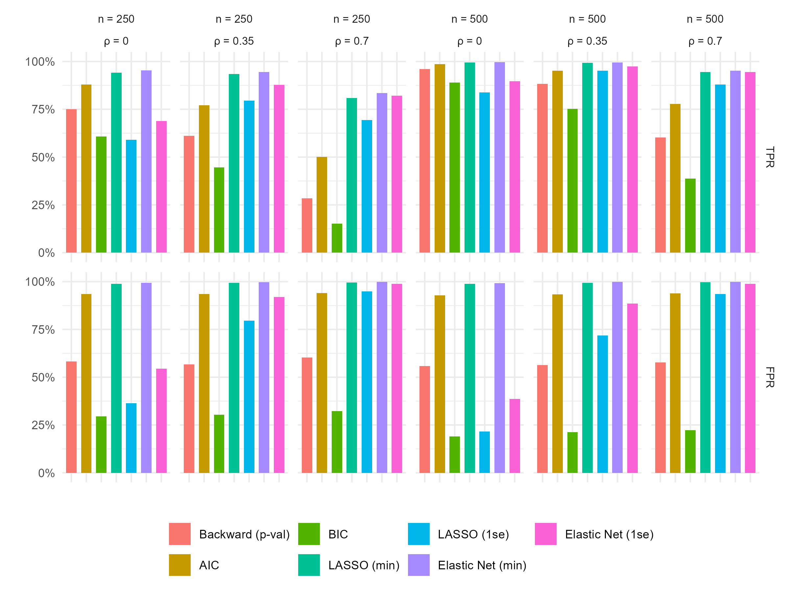
Figure 1: Overall true positive rate (TPR), defined by proportion of simulations in which all predictors with a true effect were selected and false positive rate (FPR), defined as proportion of simulations in which any predictor with a null effect was selected across simulation scenarios and variable selection methods.
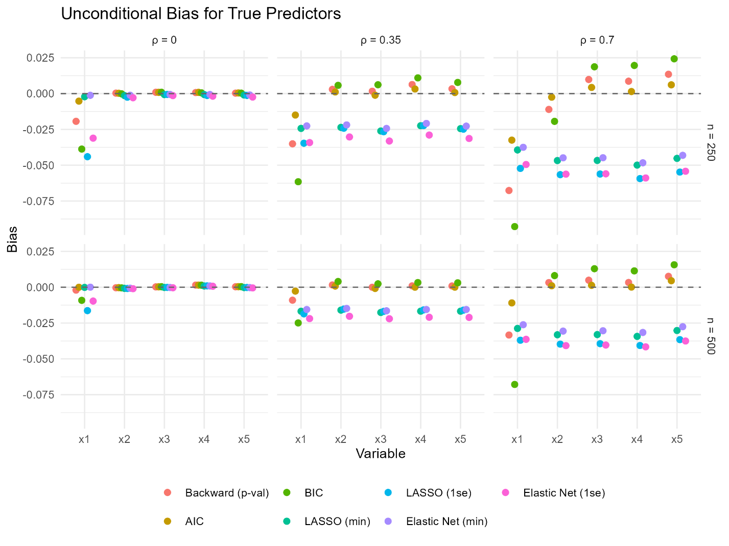
Figure 2: Bias, defined by difference between true coefficient and estimated coefficient among true predictors, across simulation scenarios and variable selection methods. Non-selected variables were imputed as zero.
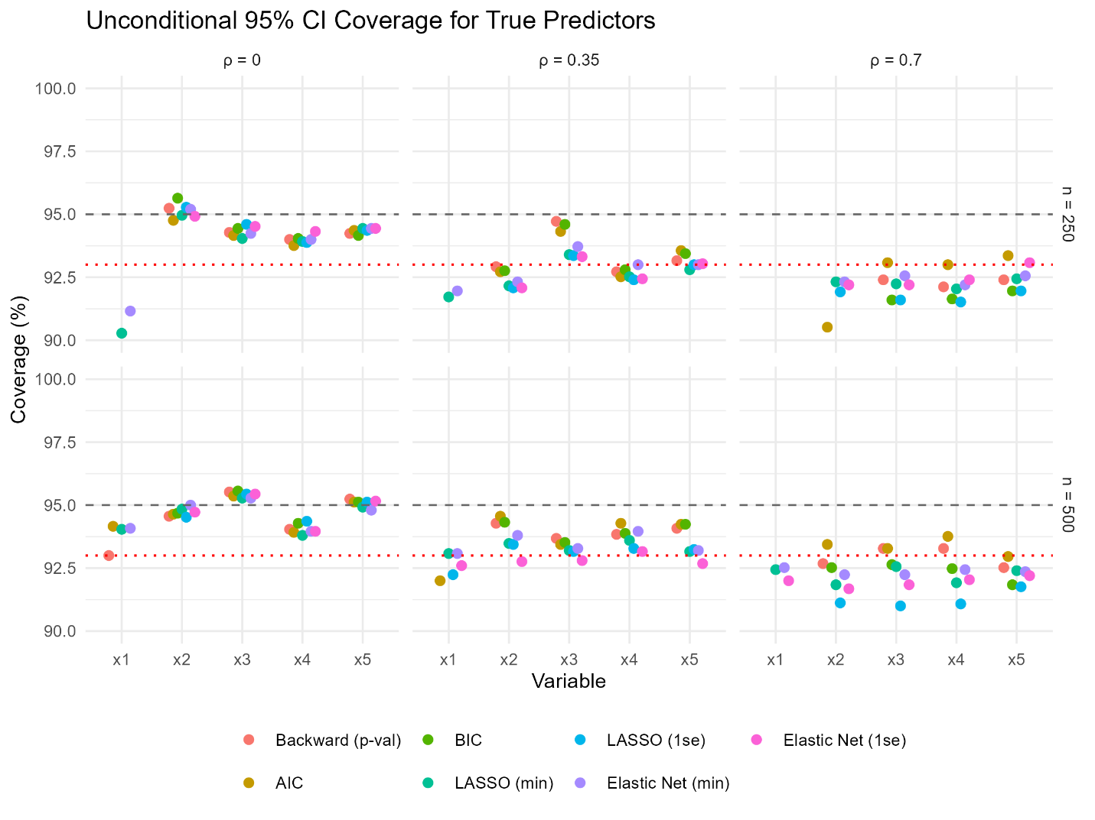
Figure 3: Coverage, defined as proportion of 95% confidence intervals covering the true coefficient value, across simulation scenarios and variable selection methods. Non-selected variables were imputed as zero. Dotted red line represents severe under-coverage threshold (93%). Coverage values below 90% excluded from the plot.

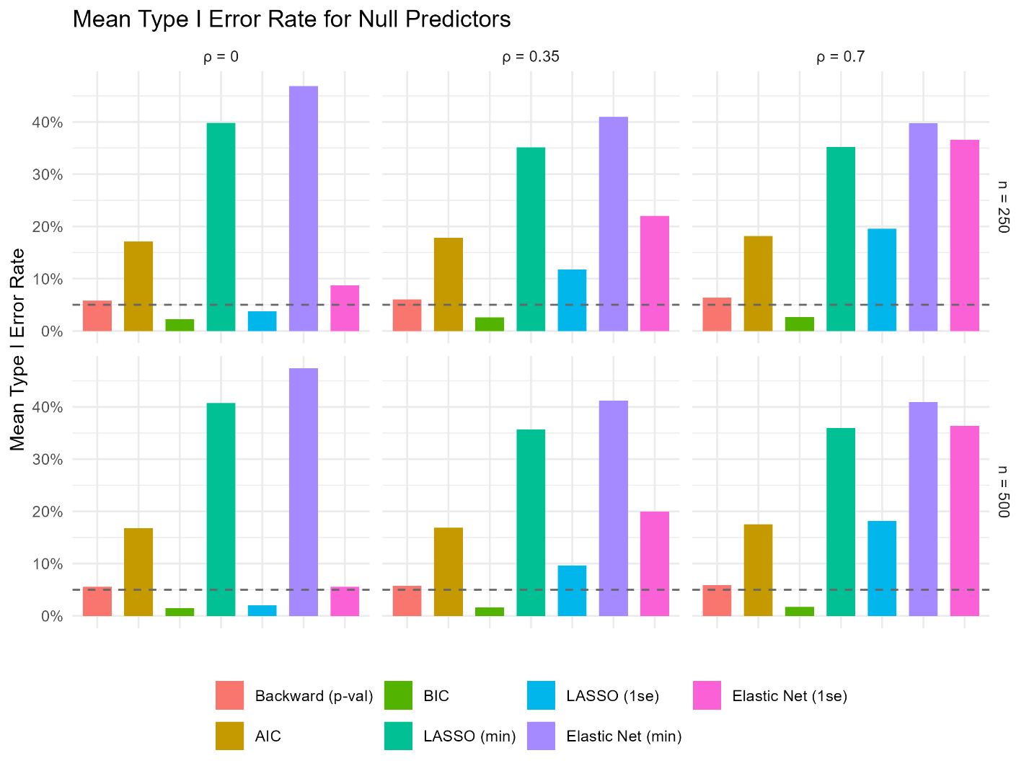
Figure 4: Type I error rate, averaged over all 15 null predictors across simulation setting and variable selection method.

Scenario | Variable | Backward (p-val) | AIC | BIC | LASSO (min) | LASSO (1se) | Elastic Net (min) | Elastic Net (1se)
n=250,  ρ=0 | x1 | 0.250 | 0.121 | 0.390 | 0.058 | 0.408 | 0.047 | 0.310
 | x2 | 0.000 | 0.000 | 0.002 | 0.000 | 0.005 | 0.000 | 0.005
 | x3 | 0.000 | 0.000 | 0.000 | 0.000 | 0.000 | 0.000 | 0.000
 | x4 | 0.000 | 0.000 | 0.000 | 0.000 | 0.000 | 0.000 | 0.000
 | x5 | 0.000 | 0.000 | 0.000 | 0.000 | 0.000 | 0.000 | 0.000
n=250,  ρ=0.35 | x1 | 0.383 | 0.227 | 0.544 | 0.066 | 0.204 | 0.056 | 0.121
 | x2 | 0.008 | 0.002 | 0.017 | 0.000 | 0.002 | 0.000 | 0.001
 | x3 | 0.000 | 0.000 | 0.000 | 0.000 | 0.000 | 0.000 | 0.000
 | x4 | 0.000 | 0.000 | 0.000 | 0.000 | 0.000 | 0.000 | 0.000
 | x5 | 0.000 | 0.000 | 0.000 | 0.000 | 0.000 | 0.000 | 0.000
n=250,  ρ=0.7 | x1 | 0.652 | 0.459 | 0.767 | 0.180 | 0.288 | 0.156 | 0.170
 | x2 | 0.127 | 0.058 | 0.190 | 0.013 | 0.024 | 0.010 | 0.012
 | x3 | 0.009 | 0.002 | 0.016 | 0.000 | 0.000 | 0.000 | 0.000
 | x4 | 0.000 | 0.000 | 0.000 | 0.000 | 0.000 | 0.000 | 0.000
 | x5 | 0.000 | 0.000 | 0.000 | 0.000 | 0.000 | 0.000 | 0.000
n=500,  ρ=0 | x1 | 0.040 | 0.014 | 0.110 | 0.006 | 0.161 | 0.003 | 0.104
 | x2 | 0.000 | 0.000 | 0.000 | 0.000 | 0.000 | 0.000 | 0.000
 | x3 | 0.000 | 0.000 | 0.000 | 0.000 | 0.000 | 0.000 | 0.000
 | x4 | 0.000 | 0.000 | 0.000 | 0.000 | 0.000 | 0.000 | 0.000
 | x5 | 0.000 | 0.000 | 0.000 | 0.000 | 0.000 | 0.000 | 0.000
n=500,  ρ=0.35 | x1 | 0.116 | 0.048 | 0.248 | 0.006 | 0.048 | 0.006 | 0.025
 | x2 | 0.000 | 0.000 | 0.000 | 0.000 | 0.000 | 0.000 | 0.000
 | x3 | 0.000 | 0.000 | 0.000 | 0.000 | 0.000 | 0.000 | 0.000
 | x4 | 0.000 | 0.000 | 0.000 | 0.000 | 0.000 | 0.000 | 0.000
 | x5 | 0.000 | 0.000 | 0.000 | 0.000 | 0.000 | 0.000 | 0.000
n=500, ρ=0.7 | x1 | 0.390 | 0.220 | 0.594 | 0.055 | 0.120 | 0.048 | 0.055
 | x2 | 0.008 | 0.002 | 0.022 | 0.000 | 0.001 | 0.000 | 0.000
 | x3 | 0.000 | 0.000 | 0.000 | 0.000 | 0.000 | 0.000 | 0.000
 | x4 | 0.000 | 0.000 | 0.000 | 0.000 | 0.000 | 0.000 | 0.000
 | x5 | 0.000 | 0.000 | 0.000 | 0.000 | 0.000 | 0.000 | 0.000
Table 1: Type II error among true predictors across simulation settings and methods
Scenario | Variable | Backward (p-val) | AIC | BIC | LASSO (min) | LASSO (1se) | Elastic Net (min) | Elastic Net (1se)
n=250, ρ=0 | x6 | 0.059 | 0.172 | 0.024 | 0.404 | 0.045 | 0.468 | 0.102
 | x7 | 0.066 | 0.192 | 0.026 | 0.408 | 0.040 | 0.470 | 0.098
 | x8 | 0.060 | 0.166 | 0.026 | 0.400 | 0.041 | 0.471 | 0.083
 | x9 | 0.055 | 0.175 | 0.022 | 0.390 | 0.032 | 0.470 | 0.086
 | x10 | 0.052 | 0.173 | 0.018 | 0.418 | 0.035 | 0.484 | 0.083
 | x11 | 0.057 | 0.173 | 0.022 | 0.398 | 0.036 | 0.474 | 0.089
 | x12 | 0.062 | 0.172 | 0.022 | 0.399 | 0.034 | 0.470 | 0.087
 | x13 | 0.055 | 0.178 | 0.022 | 0.412 | 0.033 | 0.482 | 0.081
 | x14 | 0.058 | 0.164 | 0.024 | 0.378 | 0.038 | 0.449 | 0.087
 | x15 | 0.059 | 0.180 | 0.020 | 0.406 | 0.039 | 0.469 | 0.094
 | x16 | 0.056 | 0.163 | 0.022 | 0.382 | 0.038 | 0.448 | 0.087
 | x17 | 0.062 | 0.171 | 0.031 | 0.394 | 0.042 | 0.464 | 0.083
 | x18 | 0.054 | 0.153 | 0.021 | 0.388 | 0.034 | 0.468 | 0.080
 | x19 | 0.055 | 0.164 | 0.021 | 0.387 | 0.033 | 0.460 | 0.086
 | x20 | 0.056 | 0.173 | 0.024 | 0.407 | 0.036 | 0.487 | 0.086
n=250,  ρ=0.35 | x6 | 0.056 | 0.174 | 0.024 | 0.340 | 0.099 | 0.396 | 0.203
 | x7 | 0.060 | 0.170 | 0.022 | 0.345 | 0.109 | 0.408 | 0.221
 | x8 | 0.060 | 0.175 | 0.024 | 0.336 | 0.116 | 0.394 | 0.217
 | x9 | 0.062 | 0.176 | 0.028 | 0.346 | 0.120 | 0.406 | 0.220
 | x10 | 0.065 | 0.183 | 0.029 | 0.364 | 0.126 | 0.424 | 0.230
 | x11 | 0.065 | 0.181 | 0.033 | 0.357 | 0.116 | 0.419 | 0.223
 | x12 | 0.064 | 0.187 | 0.030 | 0.358 | 0.121 | 0.408 | 0.218
 | x13 | 0.062 | 0.179 | 0.027 | 0.353 | 0.114 | 0.416 | 0.222
 | x14 | 0.065 | 0.183 | 0.026 | 0.349 | 0.121 | 0.410 | 0.216
 | x15 | 0.057 | 0.176 | 0.024 | 0.343 | 0.117 | 0.394 | 0.217
 | x16 | 0.053 | 0.170 | 0.023 | 0.359 | 0.112 | 0.418 | 0.217
 | x17 | 0.061 | 0.182 | 0.022 | 0.374 | 0.123 | 0.429 | 0.239
 | x18 | 0.056 | 0.186 | 0.020 | 0.365 | 0.126 | 0.419 | 0.228
 | x19 | 0.054 | 0.172 | 0.024 | 0.344 | 0.118 | 0.402 | 0.217
 | x20 | 0.060 | 0.180 | 0.026 | 0.338 | 0.122 | 0.401 | 0.217
n=250,  ρ=0.7 | x6 | 0.060 | 0.174 | 0.028 | 0.360 | 0.199 | 0.410 | 0.373
 | x7 | 0.055 | 0.176 | 0.025 | 0.354 | 0.202 | 0.402 | 0.377
 | x8 | 0.062 | 0.183 | 0.022 | 0.356 | 0.195 | 0.398 | 0.352
 | x9 | 0.065 | 0.182 | 0.031 | 0.362 | 0.194 | 0.408 | 0.370
 | x10 | 0.060 | 0.185 | 0.021 | 0.335 | 0.190 | 0.382 | 0.360
 | x11 | 0.065 | 0.190 | 0.027 | 0.347 | 0.197 | 0.392 | 0.361
 | x12 | 0.069 | 0.183 | 0.031 | 0.347 | 0.196 | 0.381 | 0.350
 | x13 | 0.071 | 0.178 | 0.029 | 0.357 | 0.207 | 0.401 | 0.380
 | x14 | 0.060 | 0.172 | 0.025 | 0.332 | 0.185 | 0.375 | 0.364
 | x15 | 0.063 | 0.187 | 0.026 | 0.346 | 0.201 | 0.394 | 0.364
 | x16 | 0.056 | 0.176 | 0.023 | 0.347 | 0.190 | 0.391 | 0.367
 | x17 | 0.064 | 0.175 | 0.026 | 0.361 | 0.194 | 0.410 | 0.364
 | x18 | 0.071 | 0.195 | 0.030 | 0.369 | 0.198 | 0.417 | 0.375
 | x19 | 0.059 | 0.167 | 0.027 | 0.352 | 0.193 | 0.398 | 0.366
 | x20 | 0.069 | 0.194 | 0.026 | 0.363 | 0.190 | 0.407 | 0.370
n=500,  ρ=0 | x6 | 0.057 | 0.167 | 0.015 | 0.408 | 0.021 | 0.482 | 0.058
 | x7 | 0.056 | 0.172 | 0.018 | 0.409 | 0.026 | 0.470 | 0.060
 | x8 | 0.055 | 0.163 | 0.012 | 0.402 | 0.021 | 0.466 | 0.062
 | x9 | 0.056 | 0.164 | 0.014 | 0.415 | 0.020 | 0.477 | 0.052
 | x10 | 0.051 | 0.160 | 0.012 | 0.408 | 0.015 | 0.464 | 0.056
 | x11 | 0.056 | 0.170 | 0.019 | 0.416 | 0.021 | 0.483 | 0.059
 | x12 | 0.050 | 0.167 | 0.014 | 0.412 | 0.021 | 0.485 | 0.049
 | x13 | 0.054 | 0.173 | 0.015 | 0.412 | 0.023 | 0.476 | 0.058
 | x14 | 0.055 | 0.176 | 0.012 | 0.403 | 0.018 | 0.484 | 0.050
 | x15 | 0.060 | 0.175 | 0.015 | 0.405 | 0.021 | 0.477 | 0.058
 | x16 | 0.058 | 0.164 | 0.016 | 0.408 | 0.023 | 0.471 | 0.058
 | x17 | 0.050 | 0.165 | 0.012 | 0.392 | 0.016 | 0.464 | 0.050
 | x18 | 0.057 | 0.172 | 0.014 | 0.408 | 0.020 | 0.464 | 0.058
 | x19 | 0.058 | 0.165 | 0.015 | 0.404 | 0.020 | 0.468 | 0.056
 | x20 | 0.056 | 0.167 | 0.012 | 0.406 | 0.022 | 0.471 | 0.051
n=500,  ρ=0.35 | x6 | 0.058 | 0.170 | 0.016 | 0.348 | 0.104 | 0.407 | 0.198
 | x7 | 0.056 | 0.174 | 0.015 | 0.356 | 0.098 | 0.408 | 0.198
 | x8 | 0.058 | 0.160 | 0.016 | 0.352 | 0.092 | 0.414 | 0.196
 | x9 | 0.064 | 0.172 | 0.018 | 0.376 | 0.100 | 0.422 | 0.207
 | x10 | 0.056 | 0.156 | 0.014 | 0.348 | 0.096 | 0.407 | 0.198
 | x11 | 0.052 | 0.170 | 0.016 | 0.332 | 0.090 | 0.392 | 0.186
 | x12 | 0.057 | 0.156 | 0.020 | 0.347 | 0.094 | 0.400 | 0.200
 | x13 | 0.048 | 0.168 | 0.013 | 0.365 | 0.097 | 0.420 | 0.203
 | x14 | 0.054 | 0.177 | 0.017 | 0.366 | 0.102 | 0.423 | 0.207
 | x15 | 0.063 | 0.169 | 0.017 | 0.352 | 0.088 | 0.403 | 0.195
 | x16 | 0.072 | 0.184 | 0.020 | 0.368 | 0.104 | 0.430 | 0.204
 | x17 | 0.048 | 0.168 | 0.011 | 0.353 | 0.096 | 0.404 | 0.197
 | x18 | 0.057 | 0.168 | 0.012 | 0.363 | 0.102 | 0.416 | 0.202
 | x19 | 0.052 | 0.173 | 0.016 | 0.366 | 0.093 | 0.426 | 0.204
 | x20 | 0.060 | 0.165 | 0.018 | 0.358 | 0.095 | 0.412 | 0.202
n=500,  ρ=0.7 | x6 | 0.056 | 0.169 | 0.015 | 0.353 | 0.182 | 0.401 | 0.376
 | x7 | 0.052 | 0.158 | 0.015 | 0.355 | 0.176 | 0.406 | 0.367
 | x8 | 0.064 | 0.169 | 0.018 | 0.351 | 0.178 | 0.402 | 0.357
 | x9 | 0.062 | 0.177 | 0.017 | 0.361 | 0.183 | 0.414 | 0.368
 | x10 | 0.058 | 0.175 | 0.016 | 0.352 | 0.177 | 0.399 | 0.350
 | x11 | 0.064 | 0.174 | 0.022 | 0.380 | 0.196 | 0.430 | 0.376
 | x12 | 0.055 | 0.172 | 0.015 | 0.338 | 0.170 | 0.391 | 0.358
 | x13 | 0.061 | 0.185 | 0.019 | 0.365 | 0.188 | 0.411 | 0.364
 | x14 | 0.064 | 0.192 | 0.018 | 0.362 | 0.182 | 0.422 | 0.355
 | x15 | 0.062 | 0.174 | 0.020 | 0.369 | 0.189 | 0.416 | 0.373
 | x16 | 0.056 | 0.178 | 0.016 | 0.359 | 0.185 | 0.403 | 0.361
 | x17 | 0.054 | 0.179 | 0.017 | 0.357 | 0.172 | 0.411 | 0.356
 | x18 | 0.060 | 0.174 | 0.016 | 0.364 | 0.190 | 0.415 | 0.376
 | x19 | 0.057 | 0.170 | 0.016 | 0.362 | 0.182 | 0.400 | 0.367
 | x20 | 0.056 | 0.178 | 0.017 | 0.362 | 0.179 | 0.416 | 0.357
Table 2: Type I error among null predictors across simulation settings and methods
Supplementary Tables and Figures
Scenario | Variable | Backward (p-val) | AIC | BIC | LASSO (min) | LASSO (1se) | Elastic Net (min) | Elastic Net (1se)
n=250, rho=0 | x1 | -0.0194 | -0.0053 | -0.0387 | -0.0022 | -0.0440 | -0.0012 | -0.0311
 | x2 | 0.0003 | 0.0002 | -0.0002 | -0.0014 | -0.0025 | -0.0012 | -0.0029
 | x3 | 0.0009 | 0.0009 | 0.0009 | -0.0007 | -0.0006 | -0.0006 | -0.0014
 | x4 | 0.0007 | 0.0009 | 0.0005 | -0.0007 | -0.0013 | -0.0006 | -0.0018
 | x5 | 0.0003 | 0.0004 | 0.0003 | -0.0010 | -0.0013 | -0.0010 | -0.0024
n=250, rho=0.35 | x1 | -0.0351 | -0.0150 | -0.0615 | -0.0243 | -0.0346 | -0.0226 | -0.0342
 | x2 | 0.0029 | 0.0011 | 0.0057 | -0.0236 | -0.0242 | -0.0219 | -0.0303
 | x3 | 0.0016 | -0.0012 | 0.0062 | -0.0261 | -0.0266 | -0.0243 | -0.0331
 | x4 | 0.0063 | 0.0032 | 0.0110 | -0.0224 | -0.0224 | -0.0208 | -0.0289
 | x5 | 0.0033 | 0.0007 | 0.0078 | -0.0245 | -0.0248 | -0.0227 | -0.0313
n=250, rho=0.7 | x1 | -0.0676 | -0.0325 | -0.0928 | -0.0393 | -0.0522 | -0.0375 | -0.0495
 | x2 | -0.0111 | -0.0025 | -0.0194 | -0.0467 | -0.0566 | -0.0448 | -0.0562
 | x3 | 0.0098 | 0.0043 | 0.0187 | -0.0467 | -0.0561 | -0.0448 | -0.0560
 | x4 | 0.0086 | 0.0014 | 0.0196 | -0.0499 | -0.0593 | -0.0483 | -0.0589
 | x5 | 0.0135 | 0.0061 | 0.0243 | -0.0452 | -0.0548 | -0.0431 | -0.0542
n=500, rho=0 | x1 | -0.0020 | -0.0000 | -0.0092 | -0.0001 | -0.0163 | 0.0000 | -0.0096
 | x2 | -0.0004 | -0.0003 | -0.0004 | -0.0008 | -0.0009 | -0.0007 | -0.0010
 | x3 | 0.0003 | 0.0003 | 0.0003 | -0.0002 | -0.0001 | -0.0002 | -0.0004
 | x4 | 0.0015 | 0.0015 | 0.0014 | 0.0009 | 0.0009 | 0.0009 | 0.0007
 | x5 | 0.0003 | 0.0004 | 0.0004 | -0.0002 | -0.0002 | -0.0003 | -0.0005
n=500, rho=0.35 | x1 | -0.0091 | -0.0027 | -0.0249 | -0.0168 | -0.0186 | -0.0155 | -0.0219
 | x2 | 0.0016 | 0.0008 | 0.0040 | -0.0160 | -0.0153 | -0.0148 | -0.0203
 | x3 | -0.0000 | -0.0008 | 0.0024 | -0.0176 | -0.0169 | -0.0165 | -0.0220
 | x4 | 0.0009 | 0.0000 | 0.0033 | -0.0167 | -0.0158 | -0.0155 | -0.0210
 | x5 | 0.0009 | 0.0000 | 0.0031 | -0.0167 | -0.0160 | -0.0155 | -0.0211
n=500, rho=0.7 | x1 | -0.0333 | -0.0109 | -0.0678 | -0.0287 | -0.0370 | -0.0262 | -0.0363
 | x2 | 0.0032 | 0.0010 | 0.0081 | -0.0332 | -0.0397 | -0.0306 | -0.0408
 | x3 | 0.0049 | 0.0013 | 0.0129 | -0.0330 | -0.0394 | -0.0304 | -0.0404
 | x4 | 0.0033 | 0.0001 | 0.0114 | -0.0343 | -0.0407 | -0.0316 | -0.0416
 | x5 | 0.0076 | 0.0045 | 0.0157 | -0.0302 | -0.0366 | -0.0275 | -0.0375
Table S1: Bias among true predictors across simulation scenarios and methods.

Scenario | Variable | Backward (p-val) | AIC | BIC | LASSO (min) | LASSO (1se) | Elastic Net (min) | Elastic Net (1se)
n=250, rho=0 | x1 | 71.8% | 84.6% | 57.8% | 90.3% | 56.1% | 91.2% | 66.0%
 | x2 | 95.2% | 94.8% | 95.6% | 95.0% | 95.3% | 95.2% | 94.9%
 | x3 | 94.3% | 94.2% | 94.4% | 94.0% | 94.6% | 94.2% | 94.5%
 | x4 | 94.0% | 93.8% | 94.0% | 93.9% | 93.9% | 94.0% | 94.3%
 | x5 | 94.2% | 94.4% | 94.2% | 94.4% | 94.4% | 94.4% | 94.4%
n=250, rho=0.35 | x1 | 58.6% | 74.1% | 42.6% | 91.7% | 78.5% | 92.0% | 86.1%
 | x2 | 92.9% | 92.7% | 92.8% | 92.2% | 92.1% | 92.3% | 92.1%
 | x3 | 94.7% | 94.3% | 94.6% | 93.4% | 93.4% | 93.7% | 93.3%
 | x4 | 92.7% | 92.5% | 92.8% | 92.5% | 92.4% | 93.0% | 92.4%
 | x5 | 93.2% | 93.6% | 93.4% | 92.8% | 93.0% | 93.0% | 93.0%
n=250, rho=0.7 | x1 | 31.3% | 50.8% | 19.3% | 81.0% | 70.5% | 83.2% | 82.0%
 | x2 | 83.0% | 90.5% | 76.1% | 92.3% | 91.9% | 92.3% | 92.2%
 | x3 | 92.4% | 93.1% | 91.6% | 92.2% | 91.6% | 92.6% | 92.2%
 | x4 | 92.1% | 93.0% | 91.6% | 92.0% | 91.5% | 92.2% | 92.4%
 | x5 | 92.4% | 93.4% | 92.0% | 92.4% | 92.0% | 92.6% | 93.1%
n=500, rho=0 | x1 | 93.0% | 94.2% | 86.2% | 94.0% | 81.1% | 94.1% | 86.5%
 | x2 | 94.6% | 94.6% | 94.7% | 94.8% | 94.5% | 95.0% | 94.7%
 | x3 | 95.5% | 95.4% | 95.6% | 95.3% | 95.4% | 95.3% | 95.4%
 | x4 | 94.0% | 93.9% | 94.3% | 93.8% | 94.4% | 94.0% | 94.0%
 | x5 | 95.2% | 95.1% | 95.1% | 94.9% | 95.1% | 94.8% | 95.2%
n=500, rho=0.35 | x1 | 85.4% | 92.0% | 72.7% | 93.1% | 92.2% | 93.1% | 92.6%
 | x2 | 94.3% | 94.6% | 94.3% | 93.5% | 93.4% | 93.8% | 92.8%
 | x3 | 93.7% | 93.4% | 93.5% | 93.2% | 93.2% | 93.3% | 92.8%
 | x4 | 93.8% | 94.3% | 93.9% | 93.6% | 93.3% | 94.0% | 93.2%
 | x5 | 94.1% | 94.2% | 94.2% | 93.2% | 93.2% | 93.2% | 92.7%
n=500, rho=0.7 | x1 | 57.2% | 74.2% | 36.4% | 92.4% | 87.2% | 92.5% | 92.0%
 | x2 | 92.7% | 93.4% | 92.5% | 91.8% | 91.1% | 92.2% | 91.7%
 | x3 | 93.3% | 93.3% | 92.6% | 92.6% | 91.0% | 92.2% | 91.8%
 | x4 | 93.3% | 93.8% | 92.5% | 91.9% | 91.1% | 92.4% | 92.0%
 | x5 | 92.5% | 93.0% | 91.8% | 92.4% | 91.8% | 92.4% | 92.2%
Table S2: Estimated coverage among true predictors across simulation scenarios and methods

